**WAEX Filing Program Initial Setup**

1.Navigate to Settings

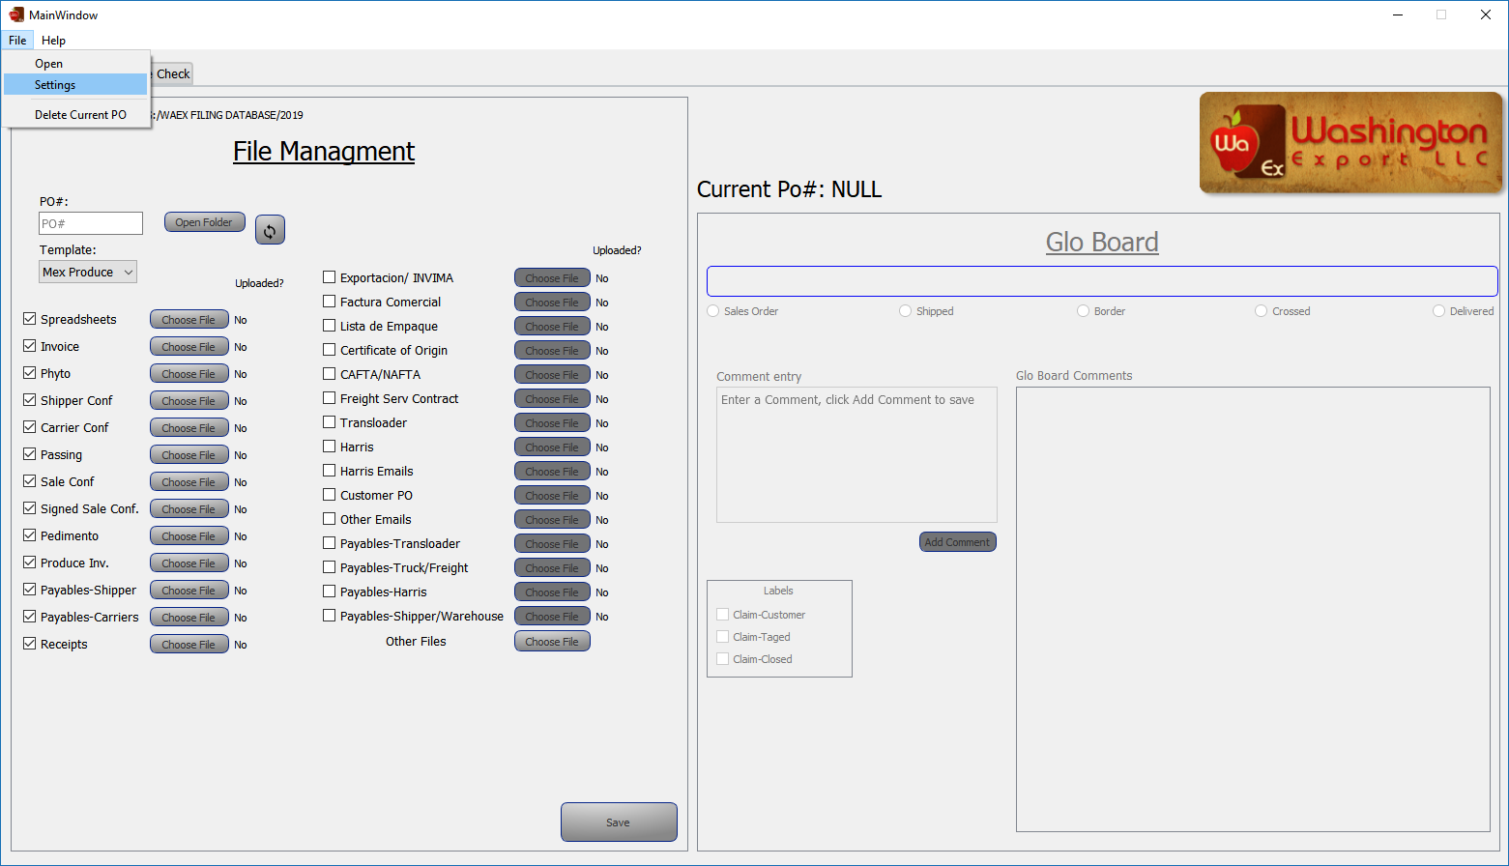

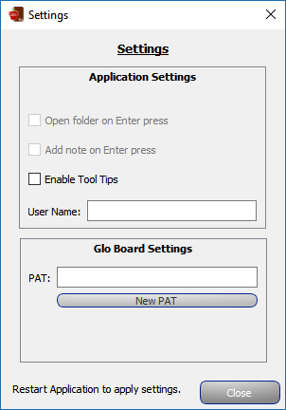2.Click “New PAT”

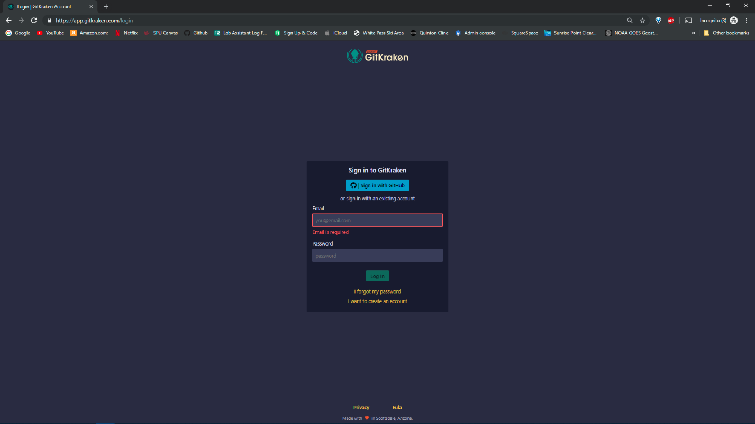3. Create a GitKraken Account or login

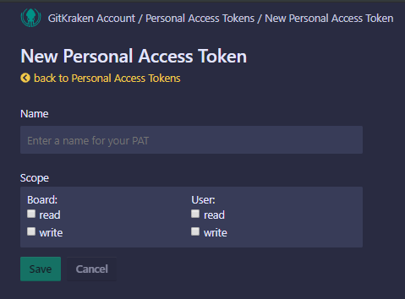4. Create the new PAT

**3.**Check

**2.**Check

**1.**Input “WAEX”

**4.**Click to Save

5.Copy PAT and paste into PAT box in the program

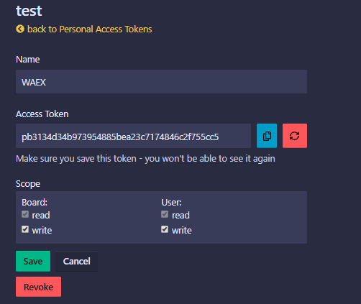

**2.**Click Save

**1.**Copy

6.Past PAT into Settings

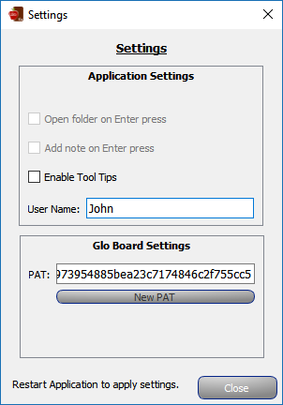

**3.**Click Close

**1.**Input First Name

**2.**Paste PAT Here

7.**Restart the application to apply the setting.**

8. Choose the Working directory

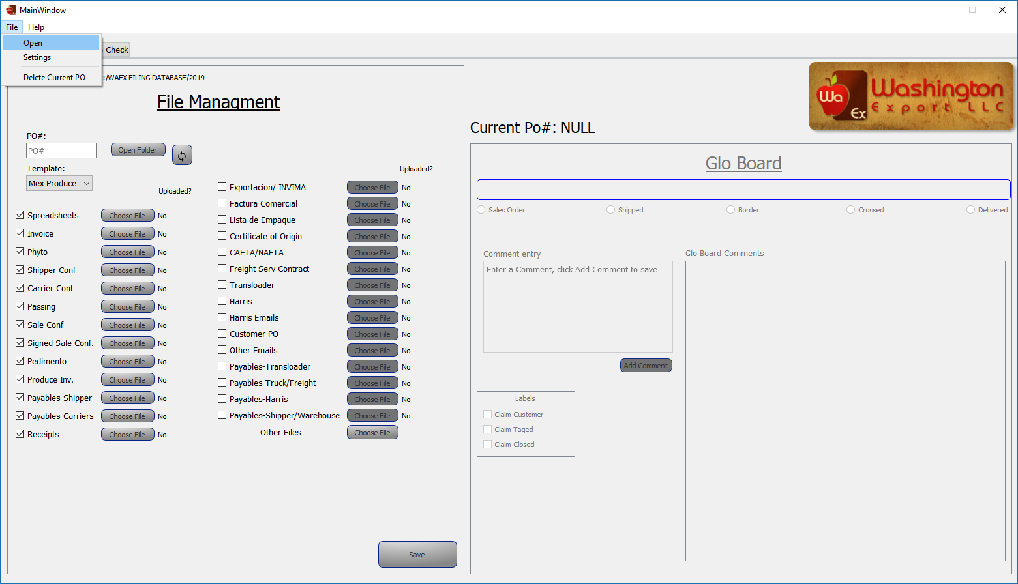

Navigate to the “WAEX FILING DATABASE” folder on the G Drive: G:\WAEX FILING DATABASE\

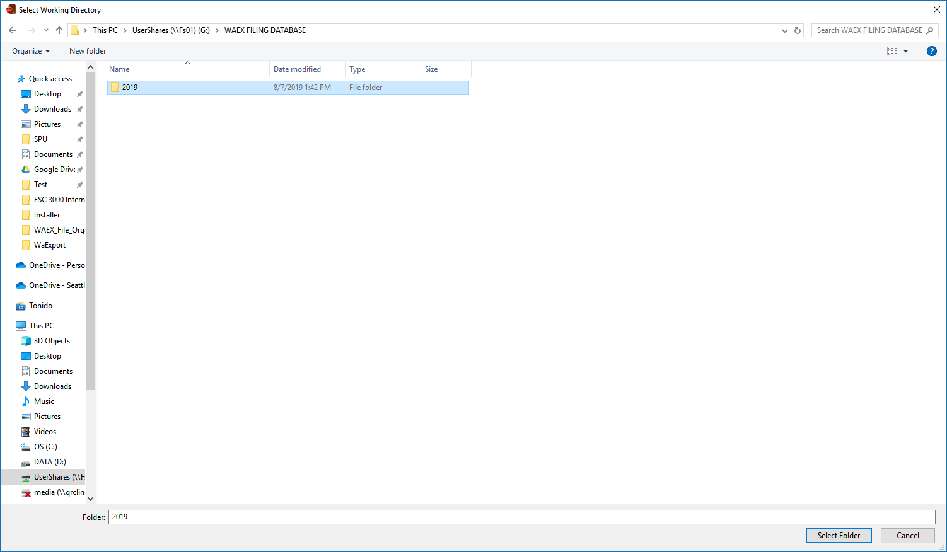

**1.**Click “Select Folder”

**1.**Select the Current Year